Chapter 10 Implementing Subprograms

The General Semantics of Calls and Returns
- The subprogram call and return operations of a language are together called its subprogram linkage.
- A subprogram call in a typical language has numerous actions associated with it.
- The call must include the mechanism for whatever parameter-passing method is used.
- If local vars are not static, the call must cause storage to be allocated for the locals declared in the called subprogram and bind those vars to that storage.
- It must save the execution status of the calling program unit.
- It must arrange to transfer control to the code of the subprogram and ensure that control to the code of the subprogram execution is completed.
- Finally, if the language allows nested subprograms, the call must cause some mechanism to be created to provide access to non-local vars that are visible to the called subprogram.

Implementing “Simple” Subprograms
- Simple means that subprograms cannot be nested and all local vars are static.
- The semantics of a call to a simple subprogram requires the following actions:
  - Save the execution status of the caller.
  - Carry out the parameter-passing process.
  - Pass the return address to the callee.
  - Transfer control to the callee.

- The semantics of a return from a simple subprogram requires the following actions:
- If pass-by-value-result parameters are used, move the current values of those parameters to their corresponding actual parameters.
- If it is a function, move the functional value to a place the caller can get it.
- Restore the execution status of the caller.
- Transfer control back to the caller.

- The call and return actions require storage for the following:
  - Status information of the caller,
  - parameters,
  - return address, and
  - functional value (if it is a function)
- These, along with the local vars and the subprogram code, form the complete set of information a subprogram needs to execute and then return control to the caller.
- A simple subprogram consists of two separate parts:
  - The actual code of the subprogram, which is constant, and
  - The local variables and data, which can change when the subprogram is executed. “Both of which have fixed sizes.”

- The format, or layout, of the non-code part of an executing subprogram is called an activation record, b/c the data it describes are only relevant during the activation of the subprogram.
- The form of an activation record is static.
- An activation record instance is a concrete example of an activation record (the collection of data for a particular subprogram activation)
- B/c languages with simple subprograms do not support recursion; there can be only one active version of a given subprogram at a time.
- Therefore, there can be only a single instance of the activation record for a subprogram.
- One possible layout for activation records is shown below.

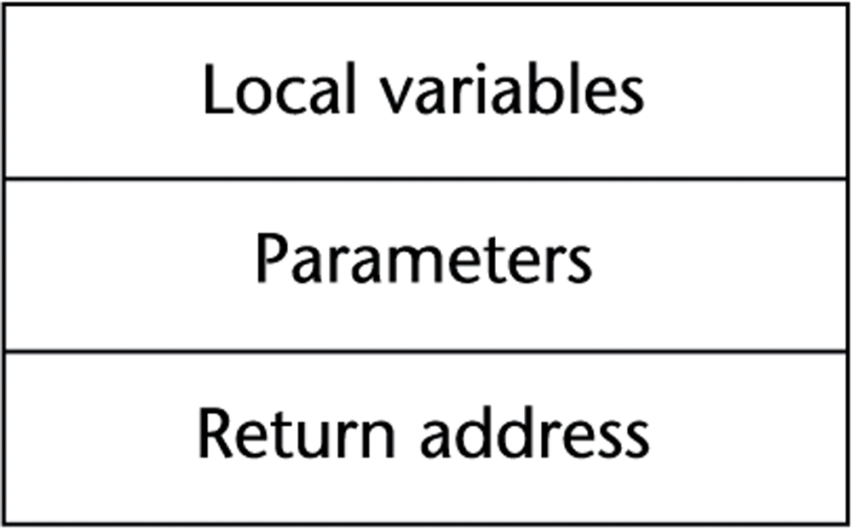

- B/c an activation record instance for a simple subprogram has a fixed size, it can be statically allocated.
- The following figure shows a program consisting of a main program and three subprograms: A, B, and C.

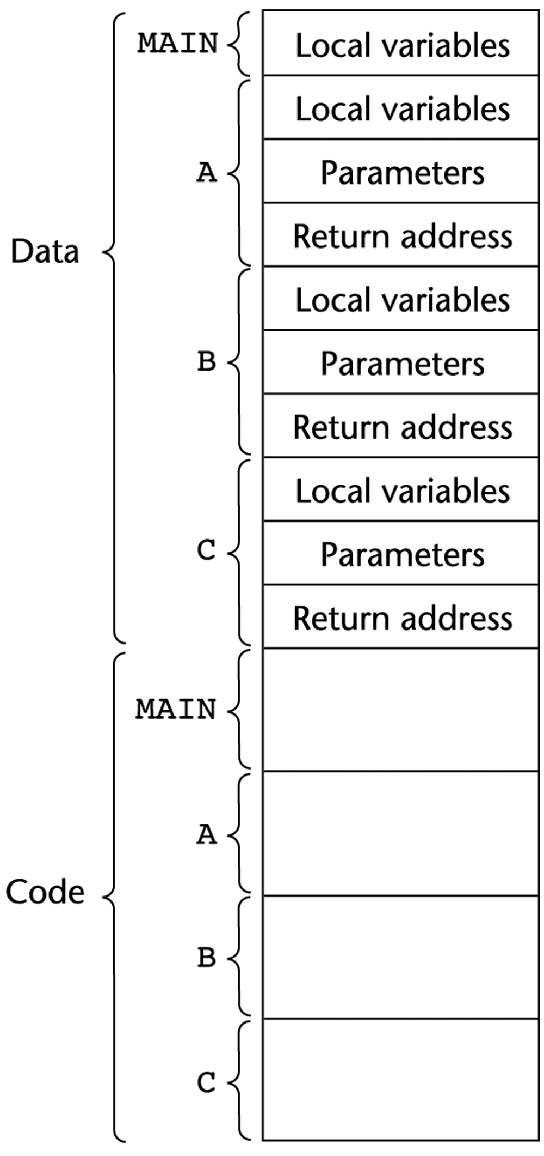
- The construction of the complete program shown above is not done entirely by the compiler.
- In fact, b/c of independent compilation, MAIN, A, B, and C may have been compiled on different days, or even in different years.
- At the time each unit is compiled, the machine code for it, along with a list of references to external subprograms is written to a file.
- The executable program shown above is put together by the linker, which is part of the O/S.
- The linker was called for MAIN, and the linker had to find the machine code programs A, B, and C, along with their activation record instances, and load them into memory with the code for MAIN.

Implementing Subprograms with Stack-Dynamic Local Variables
- One of the most important advantages of stack-dynamic local vars is support for recursion.

More Complex Activation Records
- Subprogram linkage in languages that use stack-dynamic local vars are more complex than the linkage of simple subprograms for the following reasons:
  - The compiler must generate code to cause the implicit allocation and deallocation of local variables
  - Recursion must be supported (adds the possibility of multiple simultaneous activations of a subprogram), which means there can be more than one instance of a subprogram at a given time, with one call from outside the subprogram and one or more recursive calls.
  - Recursion, therefore, requires multiple instances of activation records, one for each subprogram activation that can exist at the same time.
  - Each activation requires its own copy of the formal parameters and the dynamically allocated local vars, along with the return address.
- The format of an activation record for a given subprogram in most languages is known at compile time.
- In many cases, the size is also known for activation records b/c all local data is of fixed size.
- In languages with stack-dynamic local vars, activation record instances must be created dynamically. The following figure shows the activation record for such a language.
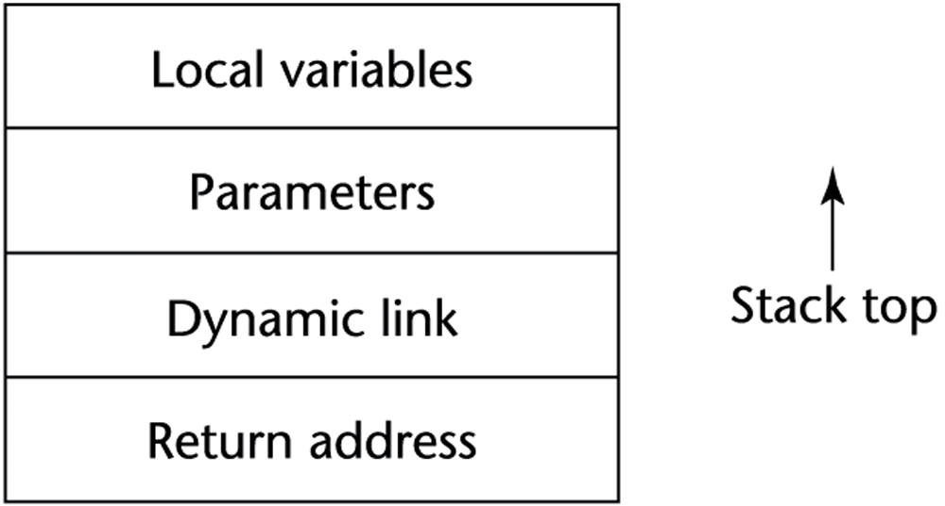
- B/c the return address, dynamic link, and parameters are placed in the activation record instance by the caller, these entries must appear first.
- The return address often consists of a ptr to the code segment of the caller and an offset address in that code segment of the instruction following the call.
- The dynamic link points to the top of an instance of the activation record of the caller.
- In static-scoped languages, this link is used in the destruction of the current activation record instance when the procedure completes its execution.
- The stack top is set to the value of the old dynamic link.
- The actual parameters in the activation record are the values or addresses provided by the caller.
- Local scalar vars are bound to storage within an activation record instance.
- Local structure vars are sometimes allocated elsewhere, and only their descriptors and a ptr to that storage are part of the activation record.
- Local vars are allocated and possibly initialized in the called subprogram, so they appear last.
- Consider the following C skeletal function:

void sub(float total, int part)
{
int list[4];
float sum;
…
}

- The activation record for sub is:
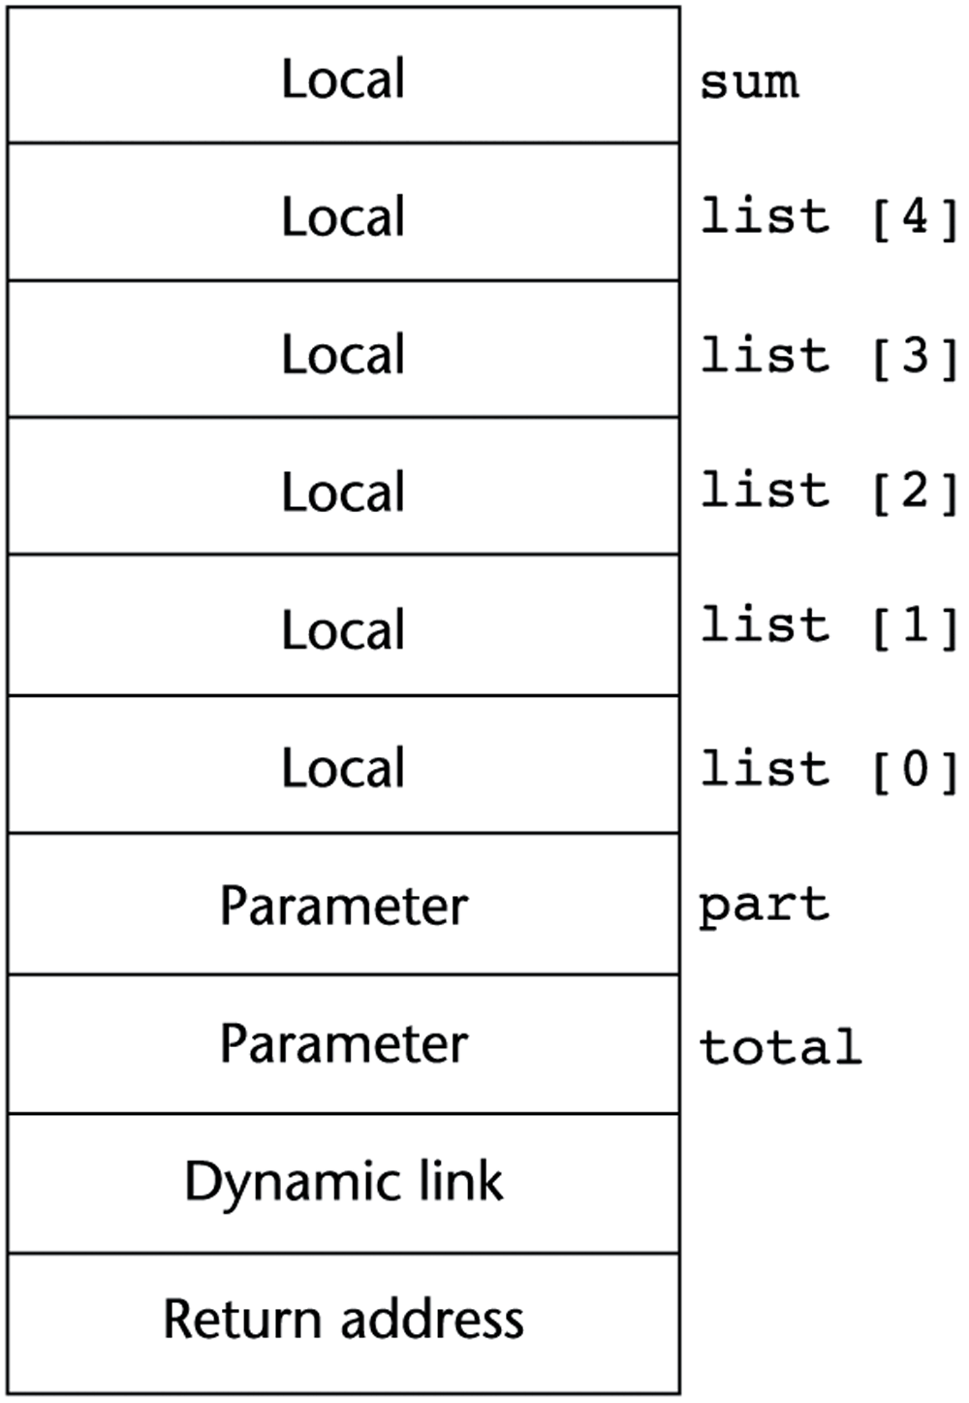

- Activating a subprogram requires the dynamic creation of an instance of the activation record for the subprogram.
- B/c of the call and return semantics specify that the subprogram last called is the first to complete, it is reasonable to create instances of these activations records on a stack.
- This stack is part of the run-time system and is called run-time stack.
- Every subprogram activation, whether recursive or non-recursive, creates a new instance of an activation record on the stack.
- This provides the required separate copies of the parameters, local vars, and return address.

An Example without Recursion
- Consider the following skeletal C program

void fun1(int x) {
int y;
... ← 2
fun3(y);
...
}
void fun2(float r) {
int s, t;
... ← 1
fun1(s);
...
}
void fun3(int q) {
... ← 3
}
void main() {
float p;
...
fun2(p);
...
}

- The sequence of procedure calls in this program is:

main calls fun2
fun2 calls fun1
fun1 calls fun3

- The stack contents for the points labeled 1, 2, and 3 are shown in the figure below:
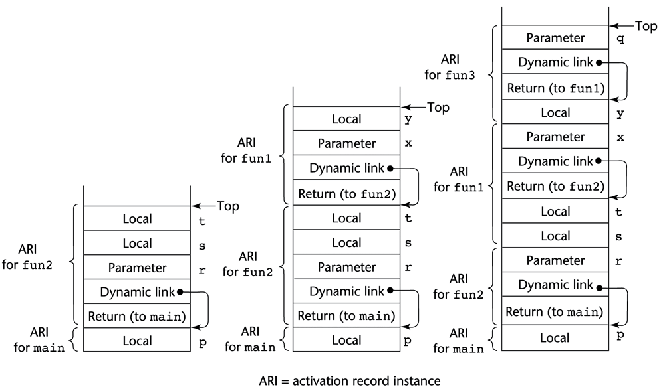

- At point 1, only ARI for main and fun2 are on the stack.
- When fun2 calls fun1, an ARI of fun1 is created on the stack.
- When fun1 calls fun3, an ARI of fun3 is created on the stack.
- When fun3’s execution ends, its ARI is removed from the stack, and the dynamic link is used to reset the stack top pointer.
- A similar process takes place when fun1 and fun2 terminate.
- After the return from the call to fun2 from main, the stack has only the ARI of main.
- In this example, we assume that the stack grows from lower addresses to higher addresses.
- The collection of dynamic links present in the stack at a given time is called the dynamic chain, or call chain.
- It represents the dynamic history of how execution got to its current position, which is always in the subprogram code whose activation record instance is on top of the stack.
- References to local vars can be represented in the code as offsets from the beginning of the activation record of the local scope.
- Such an offset is called a local_offset.
- The local_offset of a local variable can be determined by the compiler at compile time, using the order, types, and sizes of vars declared in the subprogram associated with the activation record.
- Assume that all vars take one position in the activation record.
- The first local variable declared would be allocated in the activation record two positions plus the number of parameters from the bottom (the first two positions are for the return address and the dynamic link)
- The second local var declared would be one position nearer the stack top and so forth; e.g., in fun1, the local_offset of y is 3.
- Likewise, in fun2, the local_offset of s is 3; for t is 4.

Recursion
- Consider the following C program which uses recursion:

int factorial(int n) {
<-----------------------------1
if (n <= 1)
return 1;
else return (n * factorial(n - 1));
<-----------------------------2
}
void main() {
int value;
value = factorial(3);
<-----------------------------3
}

- The activation record format for the program is shown below:
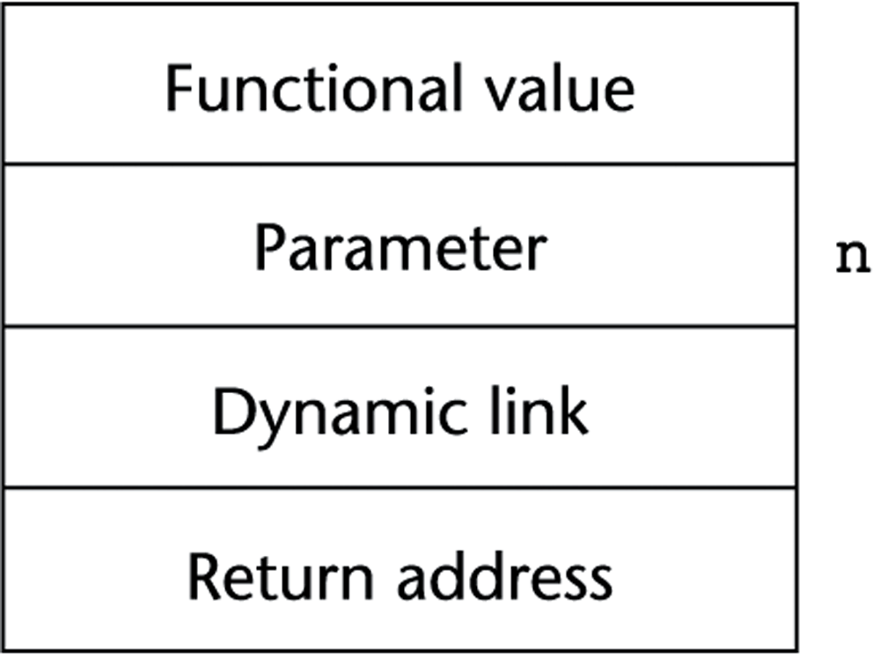

- Notice the additional entry in the ARI for the returned value of the function.
- Figure below shows the contents of the stack for the three times that execution reaches position 1 in the function factorial.
- Each shows one more activation of the function, with its functional value undefined.
- The 1st ARI has the return address to the calling function, main.
- The others have a return address to the function itself; these are for the recursive calls.
- Figure below shows the stack contents for the three times that execution reaches position 2 in the function factorial.
- Position 2 is meant to be the time after the return is executed but before the ARI has been removed from the stack.
- The 1st return from factorial returns 1. Thus, ARI for that activation has a value of 1 for its version of the parameter n.
- The result from that multiplication, 1, is returned to the 2nd activation of factorial to be multiplied by its parameter value for n, which is 2.
- This returns the value 2 to the 1st activation of factorial to be multiplied by its parameter for value n, which is 3, yielding the final functional value of 6, which is then returned to the first call to factorial in main.
- Stack contents at position 1 in factorial is shown below.
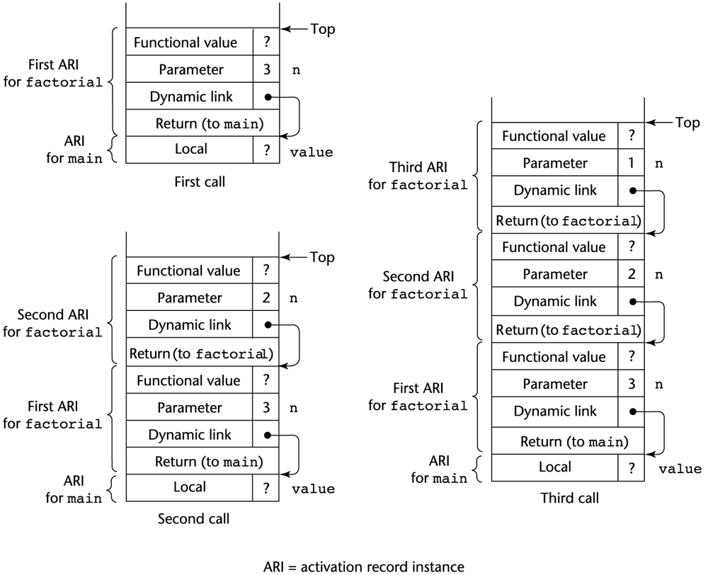

- Figure below shows the stack contents during execution of main and factorial.
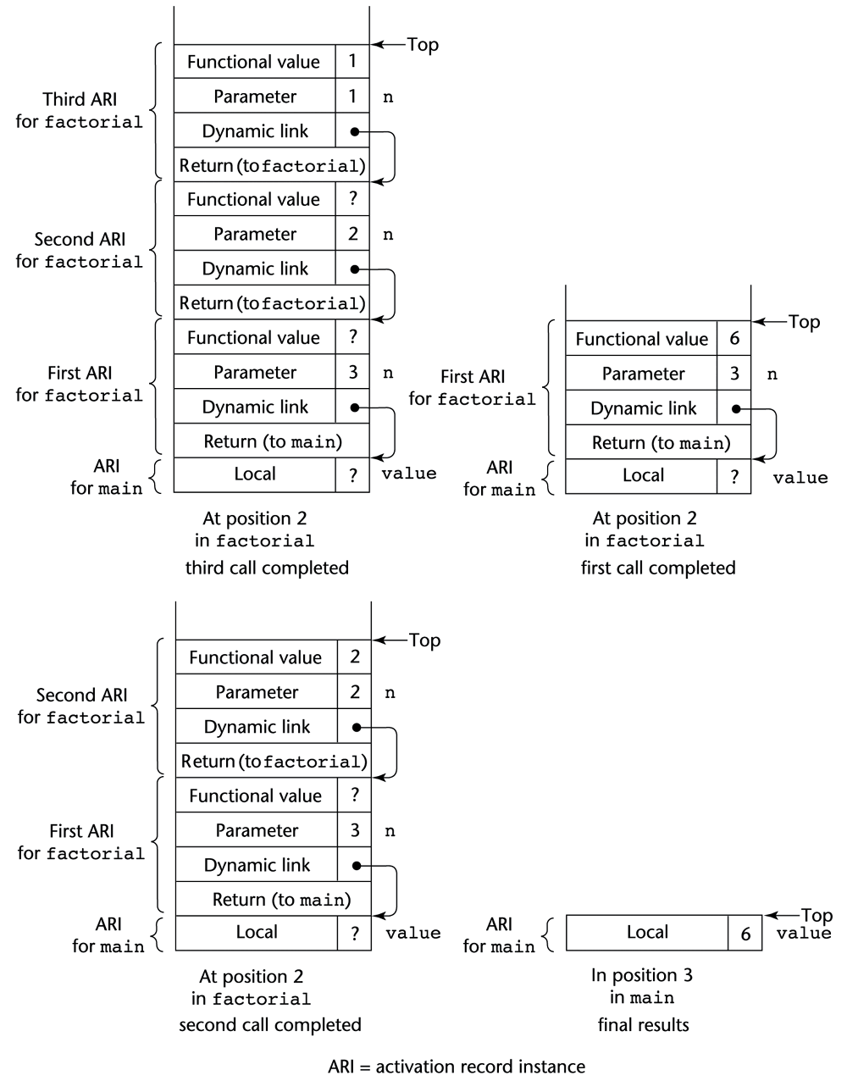

Nested Subprograms
- Some of the non-C-based static-scoped languages (e.g., Fortran 95, Ada, JavaScript) use stack-dynamic local variables and allow subprograms to be nested.

The Basics
- All variables that can be non-locally accessed reside in some activation record instance in the stack.
- The process of locating a non-local reference:
  - Find the correct activation record instance in the stack in which the var was allocated.
  - Determine the correct offset of the var within that activation record instance to access it.
- The Process of Locating a Non-local Reference:
    - Finding the correct activation record instance:
    - Only vars that are declared in static ancestor scopes are visible and can be accessed.
- Static semantic rules guarantee that all non-local variables that can be referenced have been allocated in some activation record instance that is on the stack when the reference is made.
- A subprogram is callable only when all of its static ancestor subprograms are active.
- The semantics of non-local references dictates that the correct declaration is the first one found when looking through the enclosing scopes, most closely nested first.

Static Chains
- A static chain is a chain of static links that connects certain activation record instances in the stack.
- The static link, static scope pointer, in an activation record instance for subprogram A points to one of the activation record instances of A's static parent.
- The static link appears in the activation record below the parameters.
- The static chain from an activation record instance connects it to all of its static ancestors.
- During the execution of a procedure P, the static link of its activation record instance points to an activation of P’s static program unit.
- That instance’s static link points, in turn, to P’s static grandparent program unit’s activation record instance, if there is one.
- So the static chain links all the static ancestors of an executing subprogram, in order of static parent first.
- This chain can obviously be used to implement the access to non-local vars in static-scoped languages.
- When a reference is made to a non-local var, the ARI containing the var can be found by searching the static chain until a static ancestor ARI is found that contains the var.
- B/c the nesting scope is known at compile time, the compiler can determine not only that a reference is non-local but also the length of the static chain must be followed to reach the ARI that contains the non-local object.
- A static_depth is an integer associated with a static scope whose value is the depth of nesting of that scope.

main ----- static_depth = 0
A ----- static_depth = 1
B ----- static_depth = 2

C ----- static_depth = 1
- The length of the static chain needed to reach the correct ARI for a non-local reference to a var X is exactly the difference between the static_depth of the procedure containing the reference to X and the static_depth of the procedure containing the declaration for X
- The difference is called the nesting_depth, or chain_offset, of the reference.
- The actual reference can be represented by an ordered pair of integers (chain_offset, local_offset), where chain_offset is the number of links to the correct ARI.

procedure A is
procedure B is
procedure C is
…
end; // C
…
end; // B
…
end; // A

- The static_depths of A, B, and C are 0, 1, 2, respectively.
- If procedure C references a var in A, the chain_offset of that reference would be 2 (static_depth of C minus the static_depth of A).
- If procedure C references a var in B, the chain_offset of that reference would be 1 (static_depth of C minus the static_depth of B).
- References to locals can be handled using the same mechanism, with a chain_offset of 0.

procedure MAIN_2 is
X : integer;
procedure BIGSUB is
A, B, C : integer;
procedure SUB1 is
A, D : integer;
begin { SUB1 }
A := B + C; <-----------------------1
…
end; { SUB1 }
procedure SUB2(X : integer) is
B, E : integer;
procedure SUB3 is
C, E : integer;
begin { SUB3 }
…
SUB1;
…
E := B + A: <--------------------2
end; { SUB3 }
begin { SUB2 }
…
SUB3;
…
A := D + E; <-----------------------3
end; { SUB2 }
begin { BIGSUB }
…
SUB2(7);
…
end; { BIGSUB }
begin
…
BIGSUB;
…
end; { MAIN_2 }

- The sequence of procedure calls is:
MAIN_2 calls BIGSUB
BIGSUB calls SUB2
SUB2 calls SUB3
SUB3 calls SUB1

- The stack situation when execution first arrives at point 1 in this program is shown below:
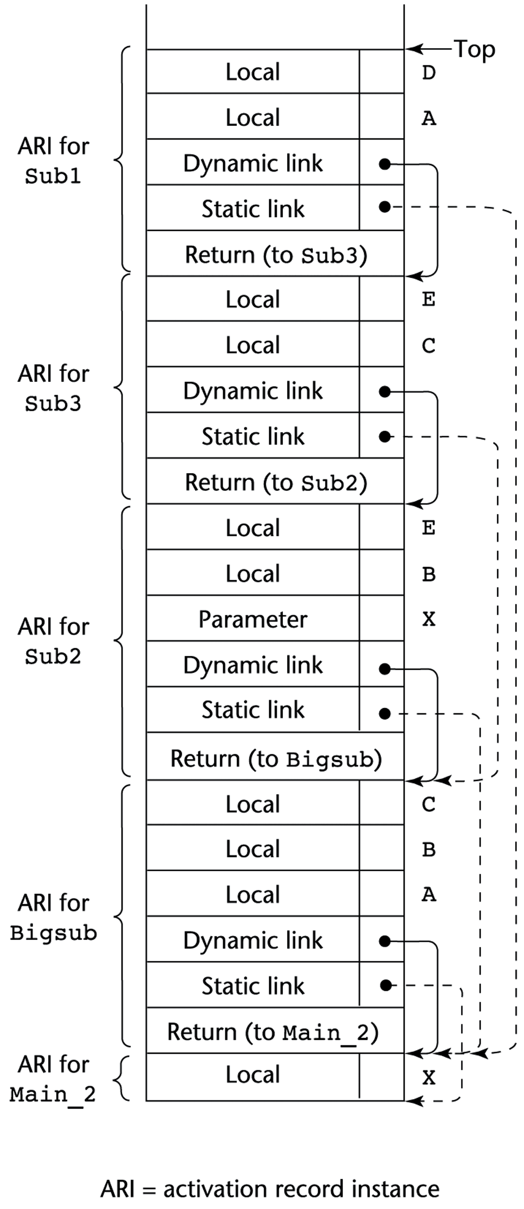

At position 1 in SUB1:
A - (0, 3)
B - (1, 4)
C - (1, 5)

At position 2 in SUB3:
E - (0, 4)
B - (1, 4)
A - (2, 3)

At position 3 in SUB2:
A - (1, 3)
D - an error
E - (0, 5)

